Skyline limo and sedan service/about us

Skyline Limo and Sedan Service is your premier luxury limousine company which serves the Los Angeles, Orange, Riverside, San Bernardino and Ventura counties. With the largest range of custom limos available for rent, we pride ourselves in having the most up to date vehicles in town, featuring the newest technologies, styles, colors, themes and more. Skyline Limo and Sedan Service is where you’ll find your luxury car or limo and with experienced chauffeurs and the most competitive pricing in town you’ll soon find out why we’re the number one choice for limo transportation and executive travel. With the ability to accommodate parties small to large, simple to elaborate, and wild to mild, we’ll help you find the limo that best suits your event and style. So if you are looking for a Platinum Style time we invite you to come experience the difference.

**SERVICES**

**THE ULTIMATE LIMOS SERVING THE LOS ANGELES, ORANGE, SAN BERNARDINO, RIVERSIDE AND VENTURA COUNTIES.**

Skyline Limo and Sedan Service is home of the Worlds more Luxurious and specialty themed limos. We are a family owned and operated business that has won international acclaim for designing, building and creating some of the worlds most exclusive limousines.

Whether you require a conventional stretch, Sedan or want to make a statement with one of our Antique or Vintage limousines, we are here to serve you. Here are just some of our services, if you have any questions then please feel free to speak to one of our trained representatives.

Skyline Limo and Sedan Service offers:

* [**Wedding Limousines**](http://www.pslimos.com/wedding-limos)
* **Bachelor Parties**
* **Bachelorette Parties**
* **Anniversary Celebrations**
* [**Airport Transportation**](http://www.pslimos.com/airport-shuttle-la)
* **Business Meetings**
* **Social Events**
* **Concerts**
* **Casinos**
* **Charters**
* [**Prom Limos**](http://www.pslimos.com/prom-limousines)
* **Sporting Events**
* **Any Special Occasion**
* **Corporate Accounts**
* **Antique Limousines**
* **Classic Limousines**
* **Vintage Limousines**
* **Vegas trips**
* **Casino trips**
* **Private engagements**
* **Winery tours**
* **Bar mitzvahs**
* **Tours around town**

**All vehicles on this website are available for:**

* **Music Videos**
* **Motion Pictures**
* **Rental**

Whether you need a stretch, sedan or SUV we can make your arrival memorable in our 1964 Rolls Royce Princess, Phantom or Maybach or one of our Cadillac Escalades or Expeditions. Take the whole group along with you in our luxury Limo Party Buses!

## ABOUT SKYLINE LIMO AND SEDAN SERVICE

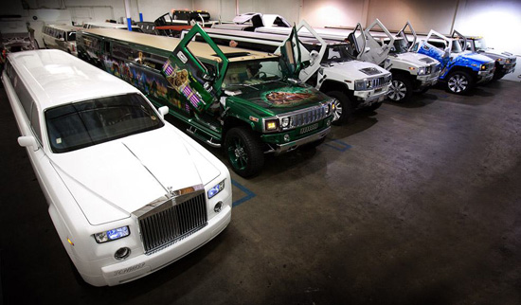

**MISSION STATEMENT: SKYLINE LIMO AND SEDAN SERVICE**

Skyline Limo and Sedan Service is your premier luxury limousine company which serves the Los Angeles, Orange, Riverside, San Bernardino and Ventura counties. With the largest range of custom limos available for rent, we pride ourselves in having the most up to date vehicles in town, featuring the newest technologies, styles, colors, themes and more. Skyline Limo and Sedan Service truly is where you’ll find your luxury car or limo and with experienced chauffeurs and the most competitive pricing in town you’ll soon find out why we’re the number one choice for limo transportation and executive travel. With the ability to accommodate parties small to large, simple to elaborate, and wild to mild, we’ll help you find the limo that best suits your event and style. So if you are looking for a Platinum Style time we invite you to come experience the difference.

Our inventory of limos include Hummers, Rolls Royce Phantoms all the way to traditional Lincoln Town cars and full on custom coaches. In addition, all of our limousines  are inspected and certified by the State Highway patrol (unlike many other limo companies), and we also hold LAX Airport passes which allows us to go in, greet and wait for our customers. So if you’re looking for a Chrysler 300 limo or a Hummer H2 that’s fully extended with Lambo doors then give us a call.

**==========================**

**Contact Information:**

Address: Skyline Limo and Sedan Service

2040 Chilton Dr.

Glendale, CA 91201

Phone: 818-590-9409

Email: [info@SkylineLSS.com](mailto:info@SkylineLSS.com)

Web: SkylineLSS.com

**==========================**

**The business hours can stay the way it is.**